**Luma Application Code Coverage & Screenshots**

This file shows 'Application Screenshot’ of the ‘Browser and Console' part. It also explaining the Code Coverage and the different Test & Concepts used in the ‘POMDemo’ Project.

**Code Coverage Details: -**

The below table shows the Concept used in the POMDemo Java Selenium Project and its purpose used in the code.

Refer below for details.

|  |  |  |  |
| --- | --- | --- | --- |
| **Sl.** | **Type/Concept** | **Use/Purpose** | **Comments** |
| 1 | TestNG | - TestNG.xml for running the TestNG suite and Class(es).  - Also used for generating the default TestNG Test Report. |  |
| 2 | **Parameterization from Config file** | - **Browser Parameterization** done from Config file: browser.  - Currently handles Chrome, Firefox & IE browsers and the driver.exe is also attached in the Project.  - *other Parameterization* are done for URL, Global Wait Time, Valid & Invalid User credentials. |  |
| 3 | **Parameterization from Excel using DataProvider** | - Username & Password Parameterization done from **Excel** Integration and **reading data** from Excel sheets.  - DataProviderInput.xlsx is also attached in the project.  Path: POMDemo\src\test\java\TestData |  |
| 4 | **Packages** | Packages are being used in the Project.  - pages: HomePage.java & LoginPage.java are used having Page Factory  - testData: Having the TestData excel file, which is used for parameterization.  - tests: List of all Test.java files  - utilities: List of other Java files, used as utilities |  |
| 5 | **Class** | The following Classes are being used, having multiple Test:   1. Test2_Login_CredentialsConfigFileValidAndInvalidTests 2. Test3_Login_DataProvider 3. Test4_HomePage_MenuOptions 4. Test5_ProductSearch_ConfigFile 5. Test6_Login_ProductSelect_Logout   - The details of the Tests are mentioned below. |  |
| 6 | **Annotation** | The below Annotations are been used:  - @BeforeSuite: To run the code before the suite.  - @Test(priority = 1): Different Tests, having the Priority order to execute.  - @AfterSuite: To run the code after the suite.  - @BeforeMethod: To run before all the Methods.  - @AfterMethod: To run after all the Methods. |  |
| 7 | **Assertion** | The below Asserts are been used:  - assertEquals  *-assertTrue* |  |
| 8 | BeforeSuite: initializeBrowser | - Retrieving the Browser as Chrome/ Firefox / Internet Explorer from the config file and opening the data.  - In case of value other than ‘Chrome/Firefox/ IE’, an error message of ‘Browser not supplied/supported.’ is displayed. |  |
| 9 | *navigateToUrl* | Function called in the BeforeSuite to open the Luma application in the browser. |  |
| 10 | **Login (Test 1)** | - This is the 1st Test, has the test has the highest Priority as 1.  - This Test is used to Login the application, where the Username & Password is retrieved form the excel or Config.properties  - Sign In button is clicked and with valid the user login, the ‘Customer Homepage’ page is validated using assert.  Or else the Login page is shown with error message. |  |
| 11 | *ReadData* | - Function called in the Login Test to retrieve the Username & Password from Excel cell A2 and B2. Note: A1 and B1 are used as Excel headers. |  |
| 12 | ***DataProvider*** | DataProvider is used to retrieve the data from the excel for login credential. |  |
| 13 | **Test4_HomePage_MenuOptions** | -After user sign-in it clicks on all home menu page and **scrolls down** the page and **scrolls up** to the Top.  - The following home menu are being accessed:  Sale, What’s New, Women, Men, Gear and Training |  |
| 14 | **Test5_ProductSearch_ConfigFile** | -The search searchLumaProduct  Is to be entered in the Search option.  - On match of both the search details, the product is shown or else No Results  - Scroll down option is also been used here. |  |
| 15 | **Test6_Login_ProductSelect_Logout** | -The Women and Men products are being searched and details are shown.  - Also, for one Women Product it is been added to Wish List and add Wishlist message is verified.  - After adding the Luma Women product in Wish List, it is removed and remove Wishlist message is verified. |  |
| 16 | **Logout (Test 4)** | - This is the last and the 4th Test, has the test has the lowest Priority as 4.  - This Test is used to Logout from the application.  - Sign Out option from the top menu is clicked under user name. |  |
| 17 | AfterSuite: tearDown | - Closing the Browser.  -Running the CopyTestOutputFolder to Performing TestOutput Backup |  |
| 18 | Screenshot | Class created in Utility to take screenshot of the page. And later pass it in the Failed Test Report. |  |
| 19 | CopyTestOutputFolder | This is used to archive the Test Run results in a folder and append the folder name with timestamp value. |  |
| 20 | Listeners | Listeners to handle and interact the events in the program. |  |
| 21 | ExtendReports | Used for styling the Test Result Reports with user configured setting, having screenshots for failed Test Cases. |  |
|  |  |  |  |

**Screenshots Details: -**

The section shows the screenshots of the project for different components and browsers.

Refer below for details.

1. **TestNG: xml file**

Screenshot: TestNG.xml file having the list of Class(es)

1. **POM: xml file**

Screenshot:

1. **Config File**

Screenshot: Having Chrome as the browser

1. **DataProviderInput.xlsx: Excel file**

Screenshot: Used to retrieve the Username & Password

**Path:** \POMDemo\src\test\java\TestData

1. **Test Result: Pass Suite**

Screenshot: TestNG Report of all the Tests

1. **Extend Report: Pass Suite**

1. **Console of Chrome Browser**

Screenshot a: Output of Console from Chrome browser

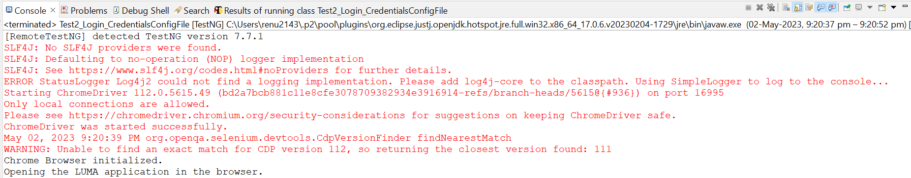

Screenshot b: Test Result

Screenshot c: **Chrome Browser launched.**

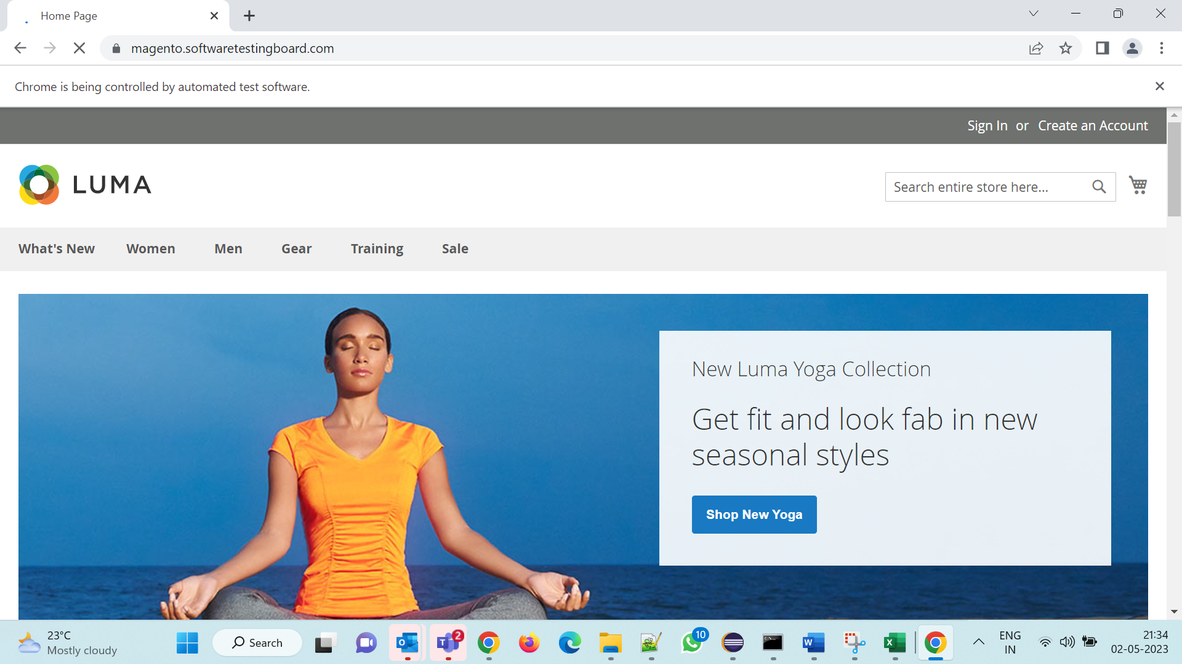

1. **Firefox Browser set in Config file**

Screenshot a: Config file

Screenshot b: **Firefox Browser launched.**

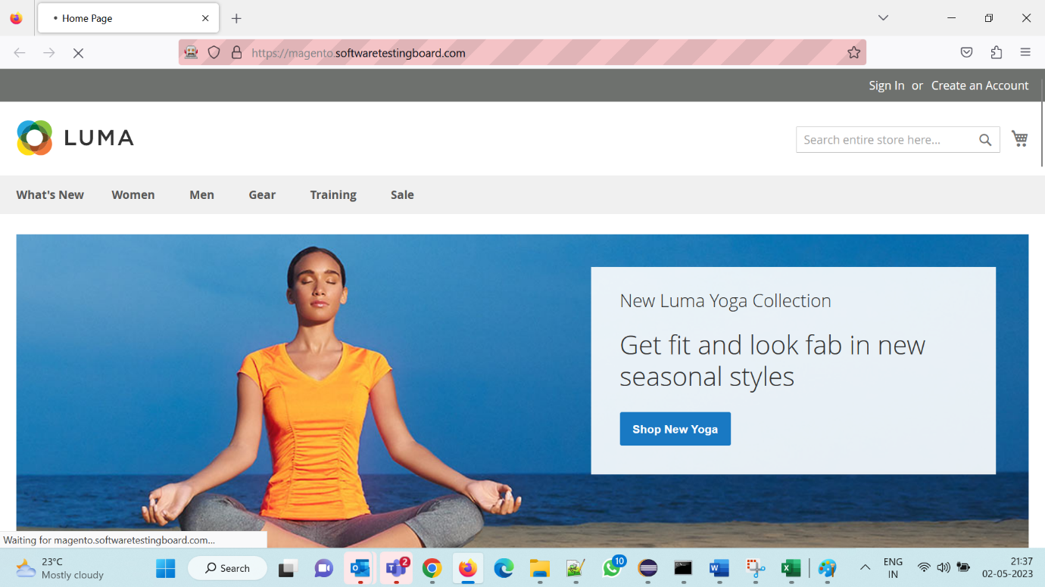

Screenshot c: **Output of Console from Firefox browser**

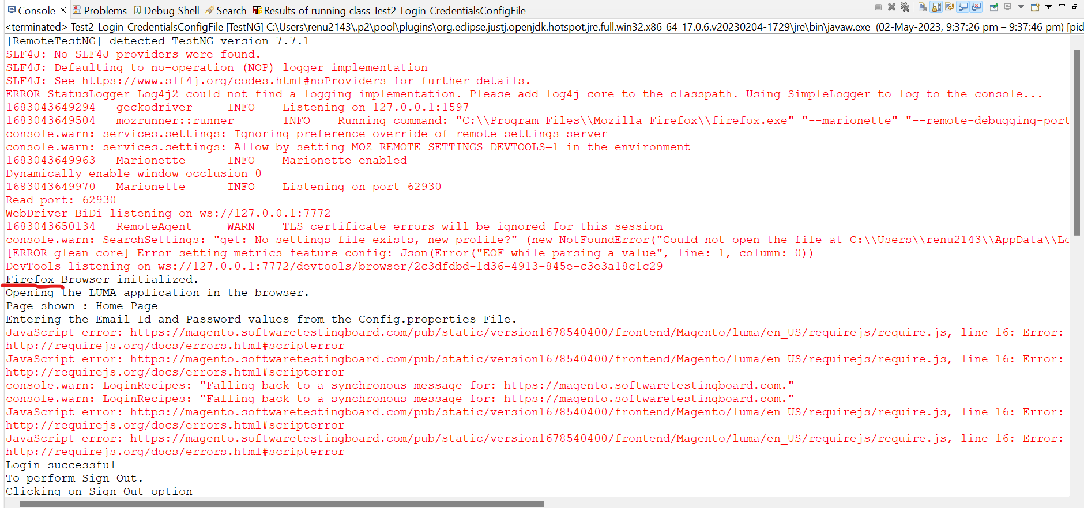

1. **IE Edge Browser set in Config file**

Screenshot a: Config file

Screenshot b: **IE Browser launched**

Screenshot c: **Output of Console from IE browser**

1. **Invalid Browser set in Config file**

Screenshot: Config file for invalid browser case

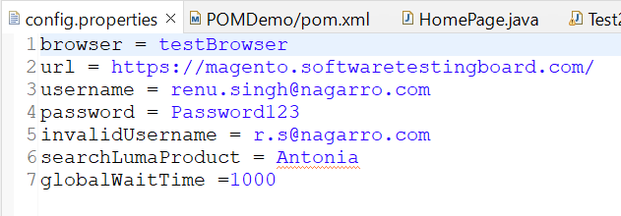

Screenshot: Console of invalid browser case

1. **Extend Reports**

Screenshot a: **TestNG File for all 3 Classes**

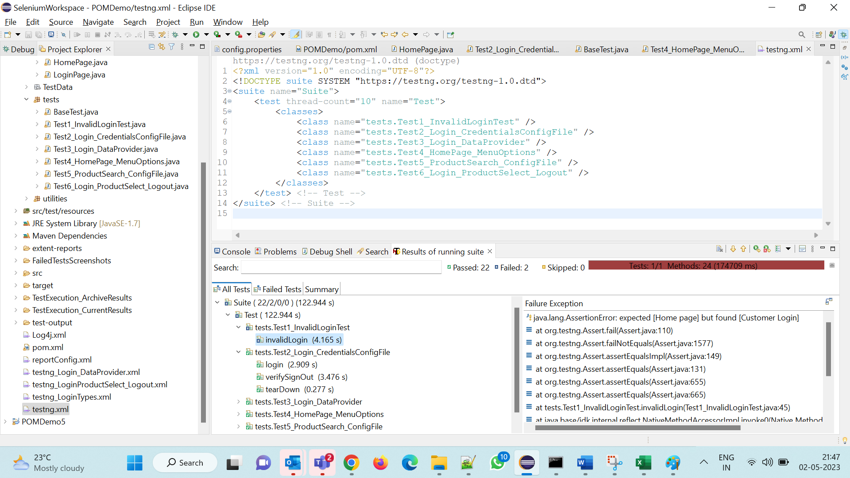

Screenshot b: **Console of all 3 Classes**

1. **Global Waits Used:**
2. Global Wait from Config file:
3. Global Wait used in the code:
4. DataProvider Used for Excel reading

Screenshot a: Data Provider Test Data File

Screenshot b: Data Provider Code

*The below code shows the Test using the dataProvider*

*DataProvider used for reading the data in the excel file.*

Screenshot c: Test Result screenshot

1. **Test Run Archive Screenshot:**

Screenshot a: Console screenshot

Screenshot b: Folder creation screenshot

Screenshot c: TestExecution ArchiveResults Folder creation screenshot

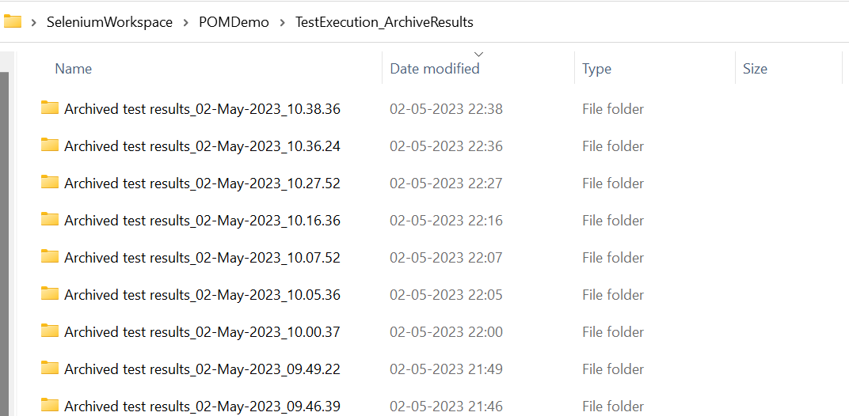

Screenshot d: TestExecution CurrentResults Folder creation screenshot

